Analysis Model Report

1- Use Case Descriptions

Student Use Cases:

1. Login
Actor : Student
Pre-condition: User has a valid account and is not logged in.
Main Flow: User enters username & password → System validates → Grants access.
Alternate Flow: Invalid credentials → System shows error.
Post-condition: User is logged into the system.

2. Browse Available Courses
Actor : Student
Pre-condition: Student is logged in.
Main Flow: Student opens course list → System displays available courses.
Alternate Flow: No courses available → System shows empty list message.
Post-condition: Student views all available courses.

3. View Course Details
Actor : Student
Pre-condition: Student selects a course from the list.
Main Flow: System displays course details (credits, instructor, schedule, capacity).
Alternate Flow: Course information missing → System shows an error.
Post-condition: Student views complete course details.

4. Register for a Course
Actor : Student
Pre-condition: Student is logged in and registration period is open.
Main Flow: Student selects course → System validates capacity, prerequisites, schedule → Registers student.
Alternate Flow: Course full / conflict / missing prerequisite → System rejects request.
Post-condition: Course is added to student schedule.

5. Drop a Course
Actor : Student
Pre-condition: Student is logged in and drop period is open.
Main Flow: Student selects a course → Clicks drop → System removes it.
Alternate Flow: Drop period closed → System denies action.
Post-condition: Course removed from schedule.

6. View Schedule
Actor : Student
Pre-condition: Student is logged in.
Main Flow: Student opens schedule → System displays weekly timetable.
Alternate Flow: No registered courses → System shows empty schedule.
Post-condition: Student sees updated schedule.

7. Submit Special Registration Request
Actor : Student
Pre-condition: Student is logged in.
Main Flow: Student submits request → System sends to instructor.
Alternate Flow: Missing info → System asks for correction.
Post-condition: Request is saved and pending review.

8. Receive Notifications
Actor : Student
Pre-condition: A system update exists.
Main Flow: Notification is generated → Student receives it.
Alternate Flow: No notifications available → No message shown.
Post-condition: Student is informed of updates.

Instructor Use Cases:

1. Login
Actor : Instructor
Pre-condition: Instructor has a valid account.
Main Flow: Instructor enters login credentials → System validates → Grants access.
Alternate Flow: Invalid login → System denies access.
Post-condition: Instructor is logged in.

2. View Assigned Courses
Actor : Instructor
Pre-condition: Instructor is logged in.
Main Flow: Instructor opens course list → System displays assigned courses.
Alternate Flow: No assigned courses → System shows message.
Post-condition: Instructor views their courses.

3. View Registered Students
Actor : Instructor
Pre-condition: Instructor selects a specific course.
Main Flow: System displays list of enrolled students.
Alternate Flow: No students registered → System shows empty list.
Post-condition: Instructor sees registered students.

4. Approve or Reject Special Requests
Actor : Instructor
Pre-condition: Students have submitted registration requests.
Main Flow: Instructor reviews request → Approves/Rejects → System saves decision.
Alternate Flow: Missing info → Instructor cannot process request.
Post-condition: Request status is updated.

5. Manage Course Details

Actor : Instructor
Pre-condition: Instructor has permission to edit details.
Main Flow: Instructor edits course info → System validates → Updates saved.
Alternate Flow: Invalid data → System prompts for correction.
Post-condition: Course details updated.

Administrator Use Cases:

1. Login

Actor : Administrator
Pre-condition: Admin has a valid account.
Main Flow: Admin enters credentials → System validates → Grants access.
Alternate Flow: Invalid login → Access denied.
Post-condition: Admin is logged in.

2. Manage Courses (Add / Edit / Delete)

Actor : Administrator
Pre-condition: Administrator is logged in and has course‑management permissions.
Main Flow:
- Administrator opens the Course Management page.
- Administrator selects one of the actions: Add, Edit, or Delete.
- Administrator enters or modifies course information (name, code, credits, capacity, schedule, prerequisites).
- system validates all the entered data.
- The system saves the update to the course catalog.
Alternate Flow:
- Course code already exists → System rejects addition.
- Required fields missing → System highlights missing fields.
- Invalid credit or capacity value → System requests correction.
Post-condition: The course catalog is updated with the new, edited, or removed course.

3. Create Course Offering

Actor : Administrator
Pre-condition: The base course already exists in the system. Administrator is logged in.
Main Flow:
- Administrator selects "Create Course Offering".
- The system shows an offering form (semester, instructor, schedule, capacity).
- Administrator enters all required data.
- The system validates schedule, instructor availability, and capacity.
- The system creates a new course offering for the selected semester.
Alternate Flow:
- Instructor is assigned to another course at the same time → System rejects offering.
- Missing information → System prompts the admin to fill missing fields.
- Invalid schedule format → System requests correction.
Post-condition: A new course offering is added and becomes available for student registration.

4. Manage User Accounts

Actor : Administrator
Pre-condition: Administrator is logged in and has account‑management permissions.
Main Flow:
- Administrator opens "User Accounts" page.
- Administrator selects Add / Edit / Delete for a student or instructor.
- Admin fills or updates user details (name, ID, email, role).
- The system validates the entered data.
- System updates the database.
Alternate Flow:
- User already exists → System prevents duplicate creation.
- Missing required fields → System highlights missing data.
- Invalid email/ID format → System rejects and requests correction.
Post-condition: User accounts are updated accurately in the system.

5. Set Registration Rules

Actor : Administrator
Pre-condition: Registration period is closed. Administrator is logged in.
Main Flow:
- Administrator opens Registration Rules page.
- Admin configures rules such as maximum credit limit, prerequisites requirements, conflict detection policies.
- The system validates rule consistency.
- The system saves all updated rules.
Alternate Flow:
- Rules conflict with existing course structures → System shows an error.
- Invalid values (e.g., negative credits) → System requests correction.
Post-condition: Updated rules are applied system‑wide and will affect upcoming registrations.

6. Open/Close Registration Period

Actor : Administrator
Pre-condition: Administrator is logged in and has scheduling permissions.
Main Flow:
- Administrator selects semester.
- Admin chooses to Open or Close registration.
- System updates semester status.
- The system notifies relevant users (students/instructors).
Alternate Flow:
- Semester not found → System shows error.
- Registration already in that status → System warns admin.
Post-condition: Registration period is successfully opened or closed for the selected semester.

2- classes and relationships :
Classes:

1.User (abstract)
- Attributes:
- userID
- name
- Email
- password
- Methods:
- login()
- logout()

2. Student (inherits User)
- Attributes:
- Level
- major
- Methods:
- registerCourse()
- dropCourse()
- browseCourses()
- viewSchedule()
- submitSpecialRequest()

3. Instructor (inherits User)
- Attributes:
- department
- Methods:
- approveRequest()
- rejectRequest()
- viewCourses()
- viewStudents()

4. Administrator (inherits User)
- Attributes:
- adminRole
- Methods:
- manageCourses()
- manageUsers()
- setRegistrationRules()

5. Course
- Attributes:
- courseCode
- Title
- Credits
- description
- Methods:
- getCourseInfo()

6. CourseOffering
- Attributes:
- offeringID
- Capacity
- currentEnrollment
- Methods:
- getOfferingInfo()

7. Registration
- Attributes:
- status (registered / rejected / pending)
- timestamp
- Methods:
- getRegistrationInfo()

8. Semester
- Attributes:
- termName
- startDate
- endDate
- registrationStatus
- Methods
- :getSemesterInfo()

9. Schedule
- Attributes:
- Days
- startTime
- endTime
- Methods:
- getSchedule()

10. SpecialRequest
- Attributes:
- requestID
- Reason
- status (pending/approved/rejected)
- Methods:
- getRequestInfo()

11. Notification
- Attributes:
- notificationID
- Message
- date
- Methods:
- showNotification()

12. RegistrationRules
- Attributes:
- maxCredits
- allowConflicts
- allowPrereqOverride
- Methods:
- getRules()
Relationships:

1. User and (student , instructor , administrator)
- student, instructor and administrator all inherit from User.
Relationship: inheritance
2. Student and Registration
- A student can have many registrations.
- Each registration belongs to exactly one student.
Relationship: 1-to-many

3. Student and SpecialRequest
- A student can submit many special requests.
- Each request is created by one student.
Relationship: 1-to-many

4. Course and CourseOffering
- A course can have many offerings.
- Each offering belongs to exactly one course.
Relationship: 1-to-many

5. Instructor and CourseOffering
- An instructor can teach many offerings.
- Each offering has one assigned instructor.
Relationship: 1-to-many

6. Instructor and SpecialRequest
- An instructor can receive many special requests from students.
- Each request is processed by one instructor.
Relationship: 1-to-many

7. CourseOffering and Semester
- A course offering belongs to one semester.
- A semester contains many course offerings.
Relationship: 1-to-many

8. CourseOffering and Schedule
- Each course offering has exactly one schedule.
- A schedule does not exist independently.
Relationship: 1-to-1 (composition)

9. Registration and CourseOffering
- A registration refers to one course offering.
- A course offering can have many registrations.
Relationship: 1-to-many

10. User and Notification
- Any user (student or instructor or admin) can receive many notifications.
- Each notification belongs to one user.
Relationship: 1-to-many

11. Administrator and RegistrationRules
- The administrator manages the system's registration rules.
- There is only one set of rules at a time.
Relationship: 1-to-1
3- Class Diagram (Analysis Level):
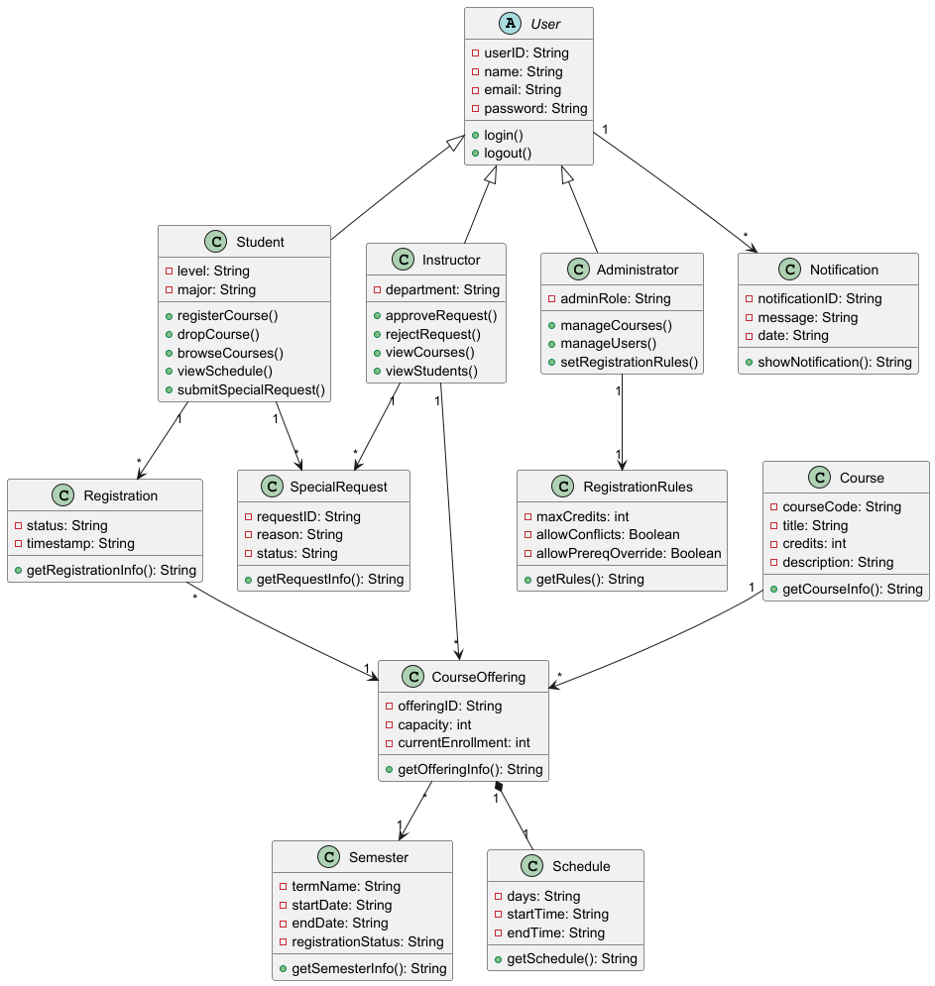

4- Sequence Diagrams:

1. Student Registration:

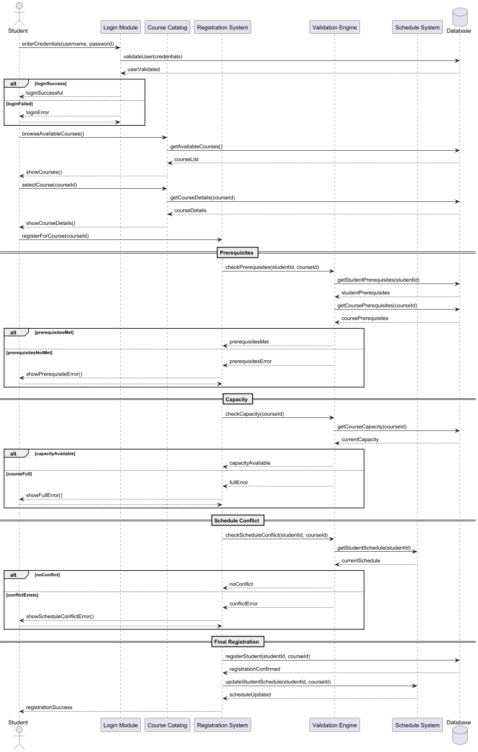

2. Instructor Approval:

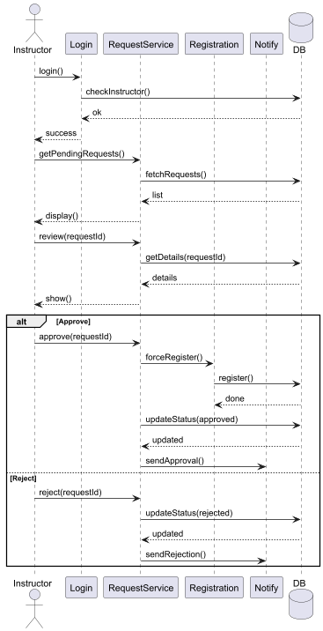

3. Admin Course Management:
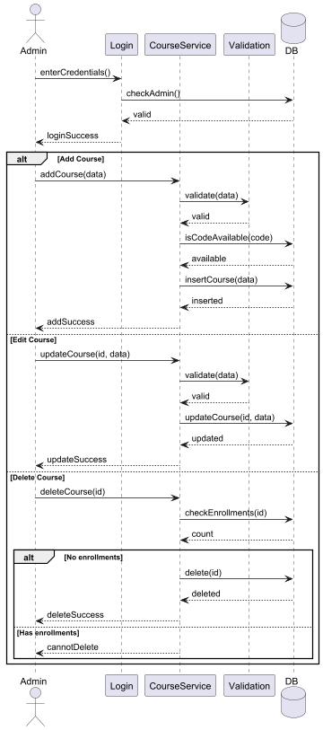

4. Registration Period:
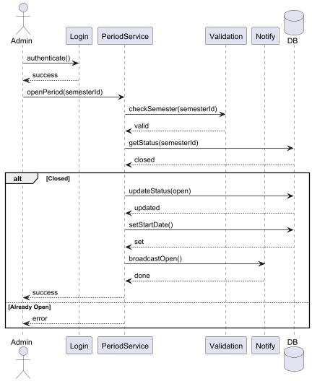

5. Special Request:
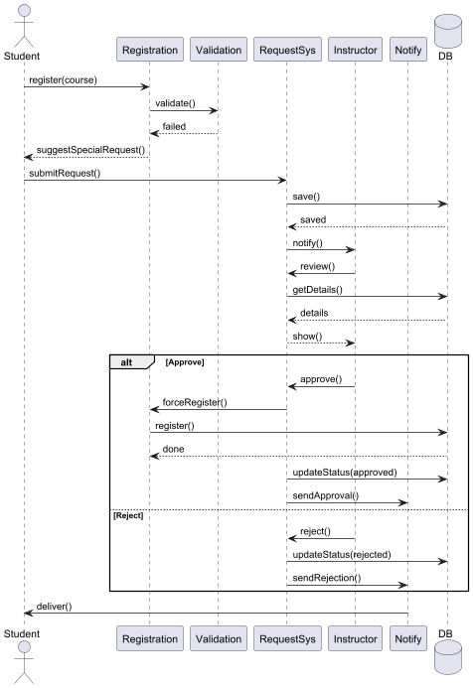

5- Activity Diagrams:

1. Student Registration:
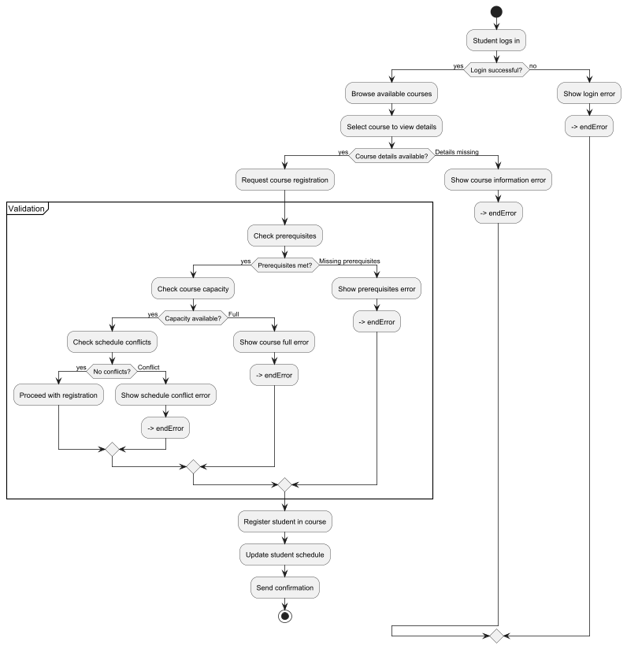

2. Instructor Approval:
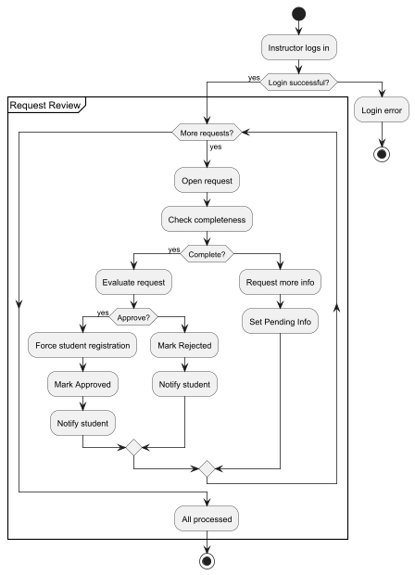

3. Admin Course Management:
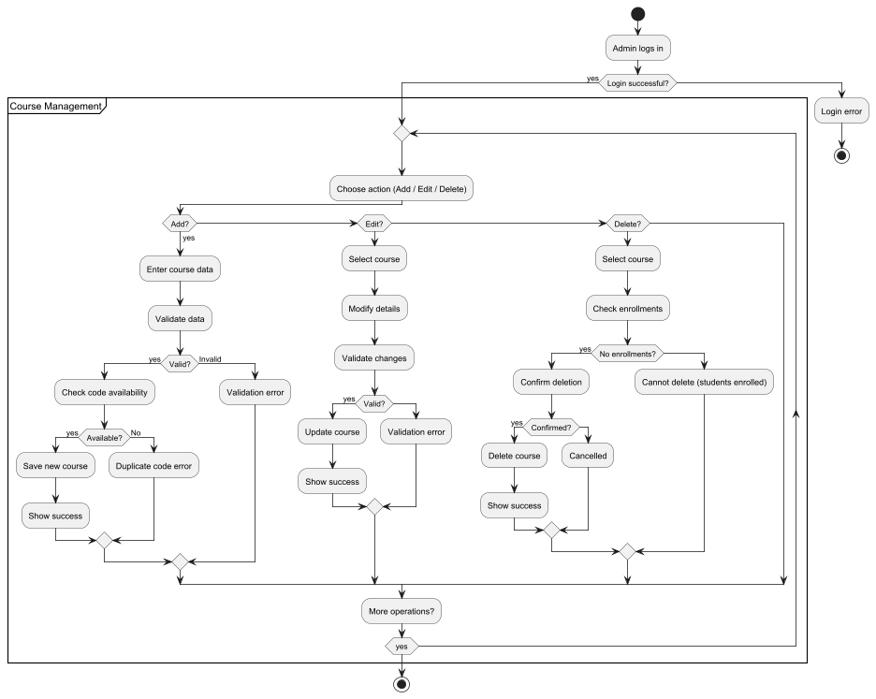

4. Registration Period:
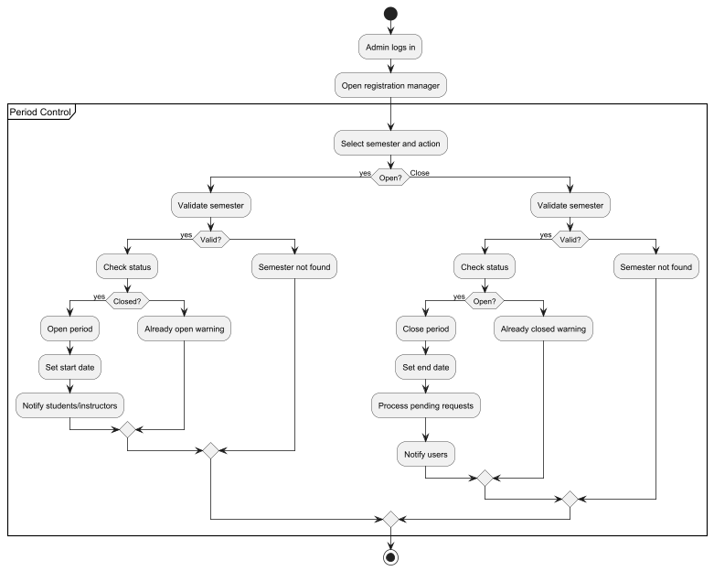

5. Special Request:
